Software Requirements Specification

January 18, 2018

**Nsure Motor Policy Issuance System**

MohanaKrishnan S

Jeya Sundari G

Akshaya M

Jose Antony Muthu S

Submitted in First Review

# Table of Contents

**Table of Contents** 2

**1.0. Purpose** 3

1.1. Introduction 3

1.2. Scope 3

1.3. Glossary 3

1.4. References 3

1.5. Overview 4

**2.0. Overall description** 4

2.1. System environment 4

2.2. Functional requirements definitions 4

2.3. Use cases 4

2.3.1. Use Case: Admin 4

2.3.2. Use Case: Agent 5

2.4. Flow charts 5

2.5. Non-functional requirements 8

**3.0. Requirement specifications**

**3.0. Requirement specifications**

3.1. Software Requirements 8

3.2. System Evolution 8

# 1.0. Purpose

## 1.1. Introduction

Insurance is a means of risk management process primarily allows individuals, businesses and other entities to protect themselves against significant potential losses and financial hardship at a reasonably affordable rate.

## 1.2. Scope

NSure Insurance project is going to be a product – oriented software solution covering every business area in Motor Insurance and has to provide the statistics defined in Client’s SRS for Motor Insurance processes.

## 1.3. Glossary

|  |  |
| --- | --- |
| **Term** | **Definition** |
| Insurer | an insurer or reinsurer authorized to write property and/or casualty insurance under the laws of any state |
| Agent | an individual who sells, services, or negotiates insurance policies either on behalf of a company or independently. |
| Underwriter | person who identifies, examines and classifies the degree of risk represented by a proposed insured in order to determine whether or not coverage should be provided and, if so, at what rate |
| Third Party | person other than the insured or insurer who has incurred losses or is entitled to receive payment due to acts or omissions of the insured. |
| **Premium** | Money charged for the insurance coverage reflecting expectation of loss. |
| **Endorsement** | an amendment or rider to a policy adjusting the coverages and taking precedence over the general contract. |
| cover note | temporary certificate showing that a person has a current insurance policy. |
| **Broker** | an individual who receives commissions from the sale and service of insurance policies. |
| **Admin** | the administration of a business, organization, etc. |
| **Policy** | a course or principle of action adopted or proposed by an organization or individual. |

## 1.4. References

www.insurance.com.my

www.tutorialspoint.com › Java

[www.spring.io](http://www.spring.io)

[www.maven.apache.org](http://www.maven.apache.org)

## 1.5. Overview

Nsure is a web based application implemented for sending customer details through agents to the verification department; further verification department will enter all the details of the customer in to the system and sends the report to the legal admin department. Legal admin department prepare policy contract and sends to customer after payment has received from the customer.

# 2.0. Overall description

This system will be completely web-based, linking to database and the remote web server from a standard web browser. An Internet connection is necessary to access the system.

## 2.1. System environment

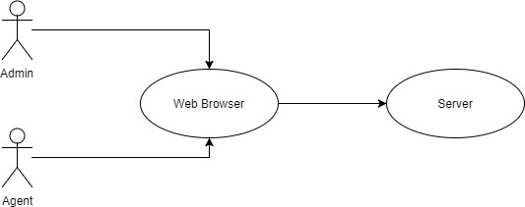

## 2.2. Functional requirements definitions

Functional Requirements are those that refer to the functionality of the system, i.e., what services it will provide to the user. Non-functional (supplementary) requirements pertain to other information needed to produce the correct system and are detailed separately.

## 2.3. Use cases

**2.3.1. Use Case: Admin**

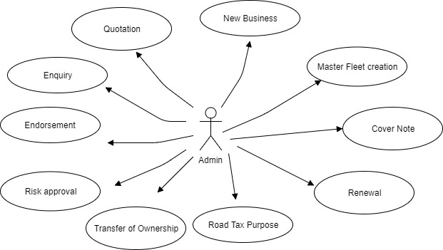

**2.3.1. Use Case: Agent**

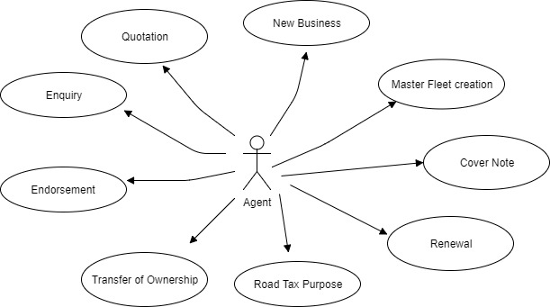

## 2.4. Flow Charts

Module 1:

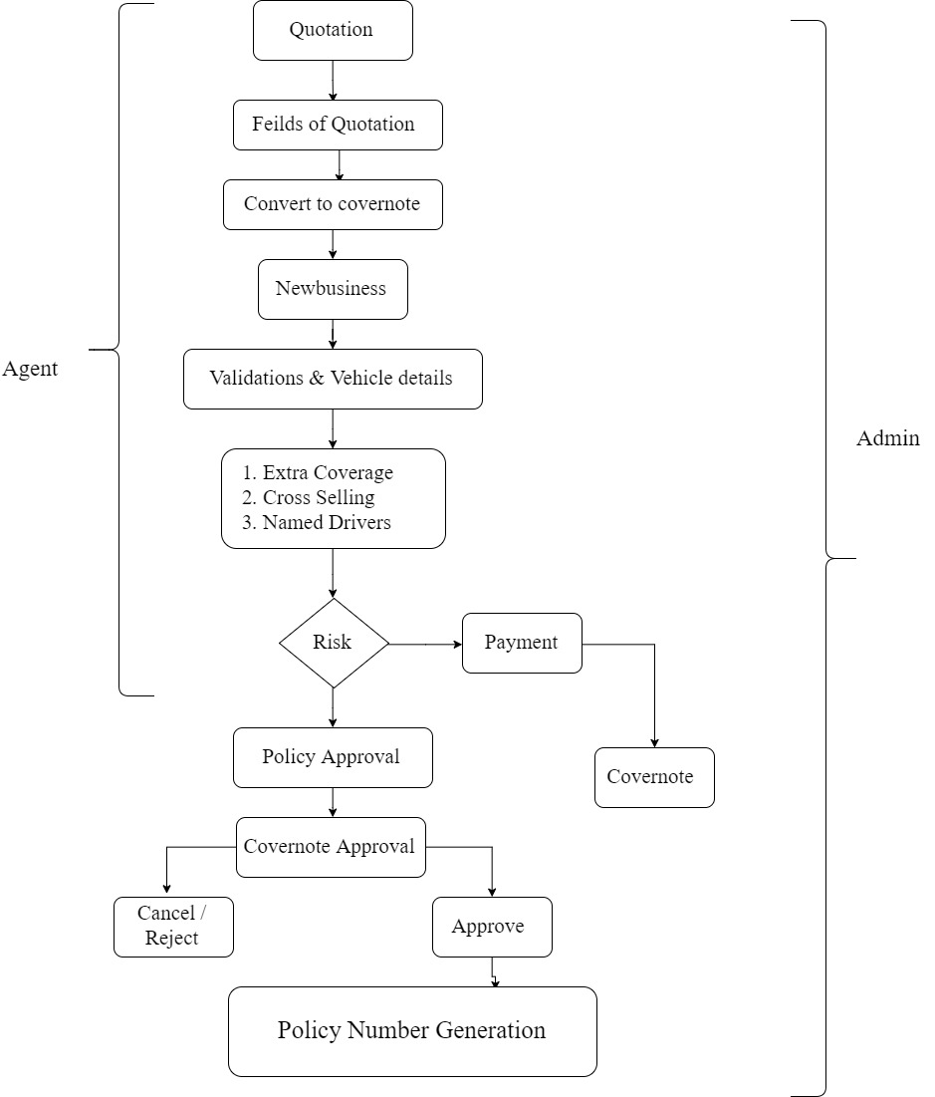

Module 2:

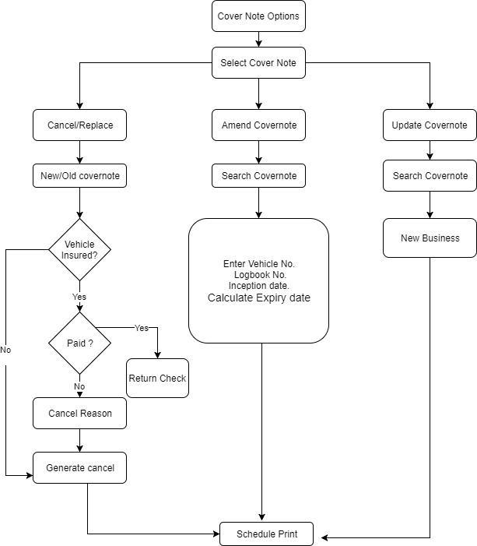

Module 3:

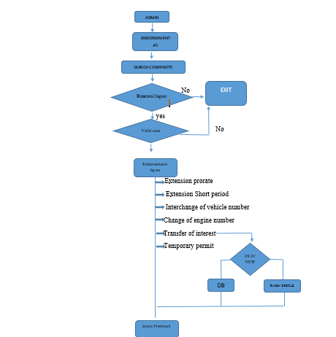

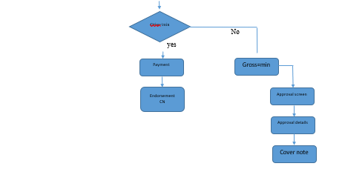

## 2.5. Non-functional requirements

There are requirements that are not functional in nature. Specifically, these are the constraints the system must work within. The web site must be compatible with both the Netscape and Internet Explorer web browsers. This system should have a PDF reader to view the cover note.

# 3.0. Requirement specifications

## 3.1. Software Requirements

The system is planned to be built using Java technology (Angular JS 4 & Spring), Jasper Reports and Oracle as database.

*Eclipse IDE

*Jaspersoft iReport

*Oracle

*Apache Tomcat

## 3.2. System Evolution

The system generates cover notes & quotations by accessing the existing client details (both motor & non motor) and premium calculations will be based on detariffication process, which will be created using web services. Schedule Print for motor products will be generated using iReport, where the pages will be designed / accessed dynamically (not static report / print), have included various functionalities in CN options & the same will integrated with schedule print & new business process.